ASSIGNMENT-2

Flask application

|  |  |
| --- | --- |
| Assignment Date | 24 september 2022 |
| Student Name | Manoj Kumar R |
| Student RollNumber | 210819205030 |
| Project Name | Plasma Donor Application |

Assigned task

1. Create a flask application.
2. Add home page and about page.
3. Add the bootstrap .
4. Add the signin page and signup page.

**Code**

**Main.py**

from flask import Flask, render_templateapp = Flask(__name__)

@app.route("/signin")

def sign_in():

return render_template("signin.html")

@app.route('/signup')

def sign_up():

retUrn render_template("signup.html")

@app.route('/')

def home():

return render_template("home.html")

@app.route('/about')

def about():

return render_template("about.html")

if __name__ == '__main__':

app.run(debug=True)

**home.html**

<!DOCTYPE html>

<html lang="en">

<head>

<link href=

"https://cdn.jsdelivr.net/npm/bootstrap@5.1.3/dist/css/bootstrap.min.css"

rel="stylesheet"

/>

<link rel="stylesheet" href="static/style.css">

</head>

<body>

<!-- NAVBAR -->

<nav class="navbar navbar-expand navbar-dark bg-primary">

<div class="container-fluid">

<a class="navbar-brand" href="./">

Welcome

</a>

<ul class="navbar-nav me-auto mb-2 mb-lg-0">

<li class="nav-item">

<a class="nav-link active" href="/">Home</a>

</li>

<li class="nav-item">

<a class="nav-link active" href="/about">About Us</a>

</li>

<li class="nav-item">

<a class="nav-link active" href="/signin">Signin</a>

</li>

<li class="nav-item">

<a class="nav-link active" href="/signup">Signup</a>

</li>

</ul>

</div>

</nav>

<script src=

"https://cdn.jsdelivr.net/npm/bootstrap@5.1.3/dist/js/bootstrap.bundle.min.js"

></script>

<br>

<h2 style="text-align:center;font-family:cursive;color:red;">Donate Plasma save life</h2>

<p align="center" style="color:black;">Plasma donate can give others second chance to live.</p>

<p align="center" style="color:black;">Be the reason for someone's heartbeat.</p>

<div class="text-center">

<img src="static\logo.png" class="rounded" alt="..." height="400px" width="450px" padding="60px">

</div>

</body>

</html>

**About.html**

<!DOCTYPE html>

<html lang="en">

<head>

<link href=

"https://cdn.jsdelivr.net/npm/bootstrap@5.1.3/dist/css/bootstrap.min.css"

rel="stylesheet"

/>

<link rel="stylesheet" href="static/style.css">

</head>

<body>

<nav class="navbar navbar-expand navbar-dark bg-primary">

<div class="container-fluid">

<a class="navbar-brand" href="./">

Welcome

</a>

<ul class="navbar-nav me-auto mb-2 mb-lg-0">

<li class="nav-item">

<a class="nav-link active" href="/">Home</a>

</li>

<li class="nav-item">

<a class="nav-link active" href="/about">About Us</a>

</li>

<li class="nav-item">

<a class="nav-link active" href="/signin">Signin</a>

</li>

<li class="nav-item">

<a class="nav-link active" href="/signup">Signup</a>

</li>

</ul>

</div>

</nav>

<script src=

"https://cdn.jsdelivr.net/npm/bootstrap@5.1.3/dist/js/bootstrap.bundle.min.js"

></script>

<br>

<div class="img">

<img src="static\about.png" alt="no">

</div>

<h1 style="text-align:center;">About Plasma Donation</h1>

<div class="pl">

<pre class="pl"><form align="center">

Plasma is the clear, straw - colored liquid portion of blood that remains after red blood cells , white blood cells,

platelets and other cellular componentsare removed . It is the single largest component of human blood, comprising

about 55percent ,and contains water, salts , enzymes , antibodies and other proteinsThe plasma protein therapeutics

industry supports volunteerism donation in all of its forms. Source plasma donation and blood donation are critically

important activities that contribute to saving lives. Source plasma and recovered plasma are used to produce therapies

that treat people with rare, chronic diseases and disorders such as primary immunodeficiency, hemophilia and a genetic

lung disease, as well as in the treatment of trauma,burns and shock. Whole blood donations most often are used locally

in hospitals for transfusions required during surgery or other medical treatment.</pre>

</form>

</div>

<div class="pl">

<form align="center">

<h2>Contact Details:</h2><br>

<h3>jagadeeshgajendran@gmail.com</h3><br>

<h3>9042683610</h3>

</form>

</div>

</body>

</html>

**Signin.html**

<!DOCTYPE html>

<html lang="en">

<head>

<meta charset="UTF-8">

<meta name="viewport" content="width=device-width, initial-scale=1.0">

<meta http-equiv="X-UA-Compatible" content="ie=edge">

<title>Document</title>

<link rel="stylesheet" href="static/style.css">

</head>

<body>

<div class="signinFrm">

<form action="" class="form">

<h1 class="title">Sign in</h1>

<div class="inputContainer">

<input type="text" class="input" placeholder="Enter mail id">

<label for="" class="label">Email</label>

</div>

<div class="inputContainer">

<input type="password" class="input" placeholder="enter password">

<label for="" class="label">Password</label>

</div>

<input type="submit" class="submitBtn" value="Sign in" formaction="/">

<a href="/signup">Don't have an account?</a>

</form>

</div>

</body>

</html>

**Signup.html**

<!DOCTYPE html>

<html lang="en">

<head>

<meta charset="UTF-8">

<meta name="viewport" content="width=device-width, initial-scale=1.0">

<meta http-equiv="X-UA-Compatible" content="ie=edge">

<title>Document</title>

<link rel="stylesheet" href="static/style.css">

</head>

<body>

<div class="signupFrm">

<form action="" class="form">

<h1 class="title">Sign up</h1>

<div class="inputContainer">

<p>Email</p><input type="text" class="input" placeholder="jagadeeshgajendran@gmail.com">

</div>

<div class="inputContainer">

<p>Username</p><input type="text" class="input" placeholder="jagadeesh">

</div>

<div class="inputContainer">

<p>Password</p><input type="password" class="input" placeholder="enter password">

</div>

<div class="inputContainer">

<label>Confirm Password</label><input type="password" class="input" placeholder="password"> </div>

<input type="checkbox" id="agree" name="agree" value="policy">

<label>I accept the Terms of Use & Privacy Policy</label>

<input type="submit" class="submitBtn" value="Sign up" formaction="/">

<a href="/signin">Already have an account</a>

</form>

</div></body>

</html>

**Outputs:**

**Homepage**

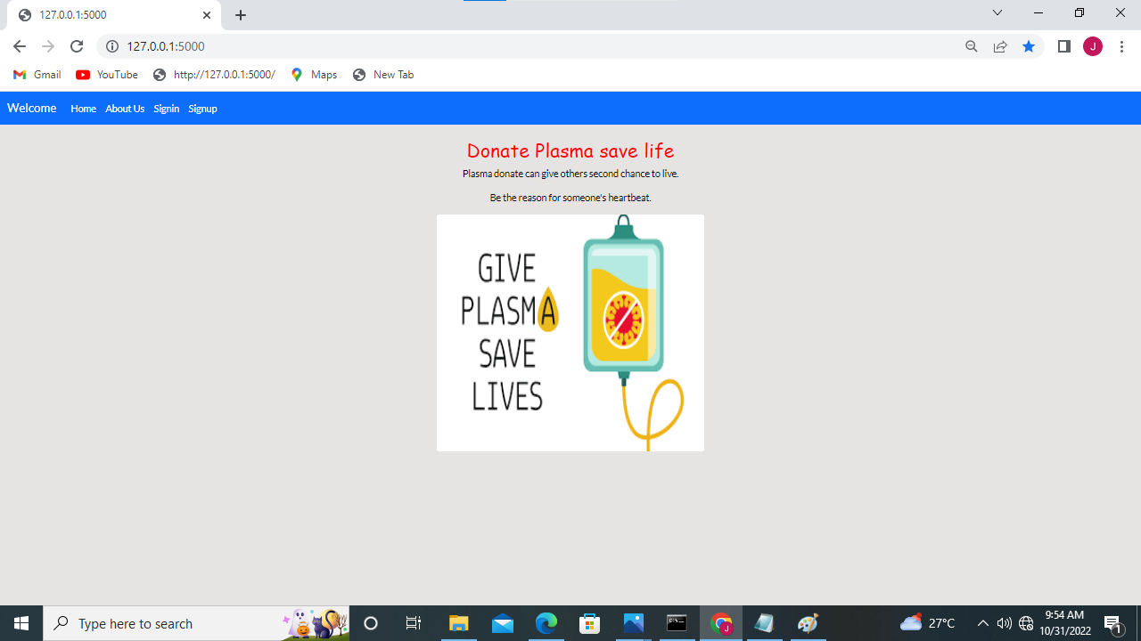

**Aboutus**

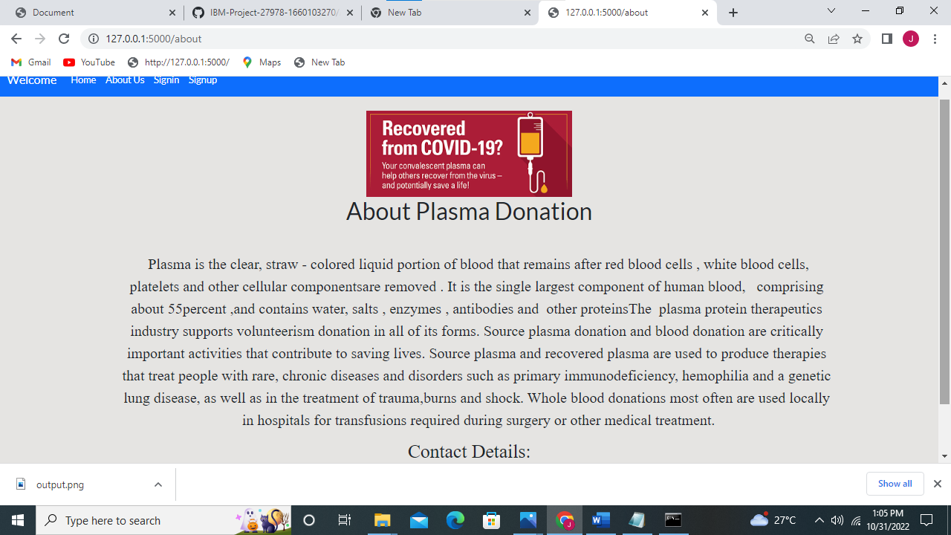

**Signinpage**

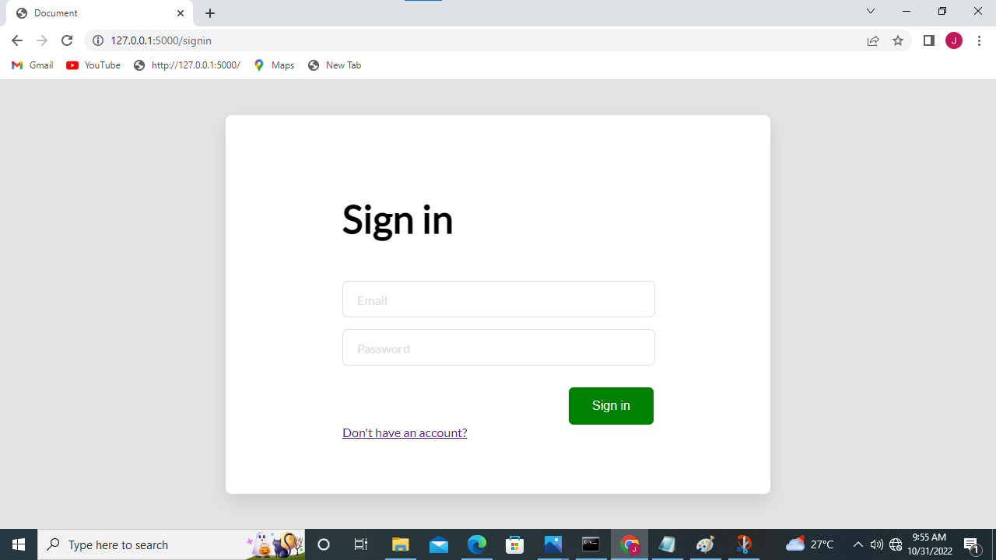

signuppage

